**Report: User Interaction Analysis for** **Movie review Website Using Microsoft Clarity**

**1. Introduction:**

This report provides an overview of the task, explaining the rationale behind integrating Auth0 with Microsoft Identity Platform for web application authentication. The introduction cogently articulates the imperative behind establishing a secure and scalable authentication solution. It underscores the significance of crafting a compelling proof of concept (POC) to vividly showcase the seamless implementation of advanced login and registration features. This report stands as a beacon, illuminating the path toward a robust and sophisticated authentication system.

**2. Research on Auth0 and Microsoft Identity:**

**What is Microsoft Identity**

Microsoft Identity, also known as the Microsoft Identity Platform, is a dedicated cloud identity service. It facilitates the development of applications that enable users and customers to sign in using their Microsoft identities or social accounts. Additionally, it authorizes access to APIs, both proprietary and those belonging to Microsoft, such as Microsoft Graph.

**What is Auth0**

Auth0 is a comprehensive identity management platform that simplifies the process of implementing authentication and authorization in applications. It provides developers with the tools to add robust user authentication features to their applications quickly. Auth0 supports various identity providers, social logins, and enterprise connections, offering flexibility in user authentication methods.

**Microsoft Identity vs Azure: Are Both the Same?**

Microsoft Identity and Azure are both services provided by Microsoft, but they serve different purposes and are not the same. Microsoft Identity is one of the many services provided under the Azure umbrella. It’s a specific service that handles identity management, allowing users to sign into applications using their Microsoft identities or social accounts.

Moreover, Azure encompasses a diverse array of essential services beyond **Microsoft identity management,** these include AI + Machine Learning, Databases, Data Analytics, and numerous others services.

**Microsoft Identity Features**

The main features of Microsoft Identity are:

1**. Azure Active Directory** **(Azure AD):**

Microsoft Identity stands as a linchpin in the realm of identity and access management, particularly due to its profound integration with Azure Active Directory (Azure AD). Beyond offering a comprehensive authentication and authorization service, this synergy extends across a spectrum of Microsoft services and third-party applications. This holistic integration ensures not only a secure access gateway but also a unified identity solution that harmonizes user experiences across diverse platforms.

2.  **Single Sign-On (SSO)**

Microsoft Identity incorporates Single Sign-On (SSO) capabilities, enabling users to log in once and access multiple applications without the need to re-enter credentials. This enhances user convenience and reduces the burden of remembering multiple sets of login information.

3.  **Multi-factor Authentication (MFA)**

Emphasizing a proactive stance on security, Microsoft Identity adopts Multi-factor Authentication (MFA) to fortify user accounts against unauthorized access and potential security threats. Going beyond traditional password-centric security, MFA incorporates additional layers of authentication, elevating the defense mechanisms. This layered approach ensures a resilient security posture, safeguarding sensitive data and user identities with a multi-faceted security shield.

4.  **Conditional Access**

Microsoft Identity introduces Conditional Access, a feature that enables organizations to define access policies based on specific conditions. This allows for granular control over user access, considering factors such as device health, location, and user roles. With Conditional Access, organizations can ensure that the right people have the right access to the right resources under the right conditions, thereby enhancing security and compliance.

**Auth0 Features**

1. **Universal Login**

Auth0 offers a Universal Login feature, providing a seamless and customizable login experience for users. This centralized login system ensures consistency across various applications, enhancing user familiarity and usability.

2. **Social Logins**

Auth0 supports integration with a wide array of social identity providers, allowing users to log in using their existing social media credentials. This feature simplifies the registration and login process, offering users a convenient and efficient way to access applications.

3. **Multi-factor Authentication (MFA)**

To bolster security, Auth0 implements Multi-factor Authentication (MFA). This additional layer of protection requires users to go through multiple verification steps, such as entering a code sent to their mobile device, ensuring a higher level of authentication and safeguarding against unauthorized access.

4. **Authorization**

Auth0 provides robust authorization features, allowing for fine-grained access control and the implementation of sophisticated authorization policies. This ensures that users only have access to the resources and features they are authorized to use, enhancing overall security.

**Use cases for Microsoft Identity**:

* Provides a comprehensive identity management solution for applications and services.
* Includes single sign-on (SSO), allowing users to authenticate once and gain access to multiple applications.
* Offers conditional access, enabling organizations to enforce policies that control access to applications based on a variety of conditions, such as user location and device state.

**Use cases for Auth0**:

* Provides a universal identity platform for secure authentication in applications.
* Supports social logins, allowing users to authenticate using their existing social media accounts.
* Supports multi-factor authentication, adding an extra layer of security by requiring users to provide two or more pieces of evidence to authenticate their identity.

**The Microsoft Identity Pros**

1. **Azure Integration:** Seamlessly integrates with other Azure services.
2. **Single Sign-On (SSO):** Enhances user experience with single sign-on capabilities.
3. **Conditional Access:** Allows granular control over access policies.

**Microsoft Identity Cons**

1. **Complexity:** The extensive feature set may be overwhelming for simpler applications.
2. **Azure-Centric**: Primarily designed for Azure-centric environments.

**Auth0 Pros**

1. **Flexible Integration:** Easily integrates with various identity providers.
2. **Universal Login**: Provides a customizable and secure universal login experience.
3. **Comprehensive Documentation**: Well-documented with extensive resources.

**Auth0 Cons**

1. **Cost:** Depending on usage, costs may escalate.
2. **Learning Curve:** Advanced features may require time to master.

This section provides an overview of Auth0 and Microsoft Identity, their features, differences, and the distinct advantages and disadvantages associated with each solution.

**3. Identified Key Features:**

**Auth0 Key Features**

1. Universal Identity Platform: Auth0 provides a unified platform for identity management across applications.
2. Extensive Social Identity Providers: Supports integration with a wide array of social identity providers.
3. Rules Engine: Allows developers to customize and extend identity management logic.

**Microsoft Identity Key Features**

1. Azure AD B2C: Enables businesses to customize and control how customers sign up, sign in, and manage their profiles.
2. Azure AD Connect: Facilitates integration between on-premises directories and Azure AD.
3. Conditional Access Policies: Allows organizations to enforce specific access conditions based on various parameters.

**4. Setup and Configuration:**

**Set up Microsoft Clarity:**

1. **Install Tracking Code**: Each website added to your Clarity account has a unique tracking code. This code can be added to multiple subdomains of your website.
2. **Choose Installation Method**: There are three ways to install Clarity:
   * **Manual Installation**: Select ‘Get tracking code’ and paste it into the <head> section of your website or web app.
   * **Third-Party Platform Installation**: Clarity can be installed on platforms like Shopify, SquareSpace, Wix, WordPress, etc. If your platform isn’t listed, you can submit a request for it.
   * **Share Code with Team Member**: If you prefer, you can share the code with a team member who can help set up Clarity. An email with the tracking code and setup instructions will be sent to them.

We've got Microsoft Clarity all set up and running smoothly to track how users are interacting with our movie review website. Each feature and button has its own custom tracking in place to make sure we capture every click and interaction accurately.

**Integrate Microsoft Clarity with Google Analytics**:

* + **Navigate to the Integration Page:** Visit the Google Analytics integration section on Clarity and select ‘Get Started’. You’ll be redirected to Google for authentication. Choose an existing account or use another account**.**
  + **Set Up the Connection:** A dialog box will appear. Select the specific web property you want to share data with Clarity. If your site is in the ‘Site to connect’ list, select it and click ‘Save’. If not, enter your site details manually**.**
  + **Access Enhanced Data:** After integration, a new Google Analytics tab will appear in your projects. Clarity will add a unique dimension to Google Analytics, providing a URL for each page session, allowing direct access to Session Recordings and Heatmaps.

1. **Data Analysis:**

****Data collected from Microsoft Clarity provided valuable insights into user interactions on the Movie review website:

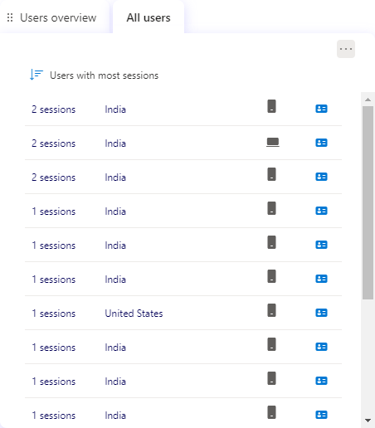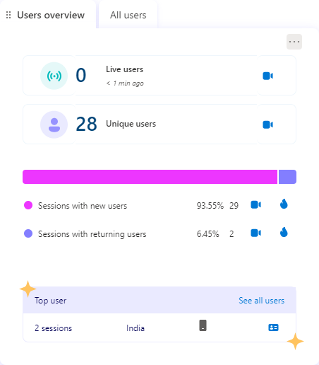

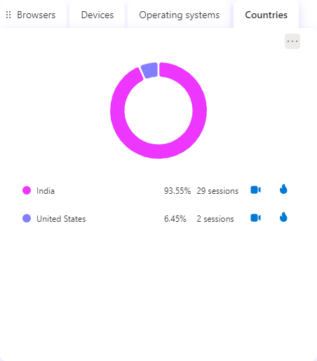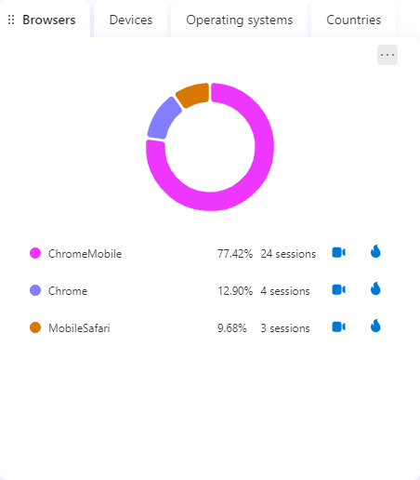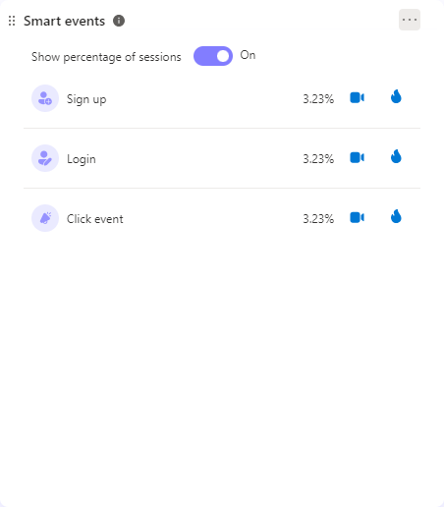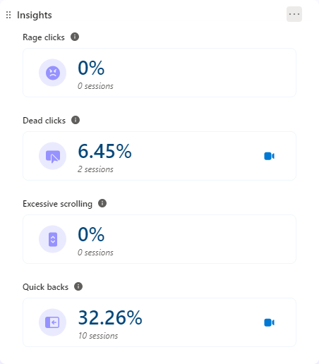

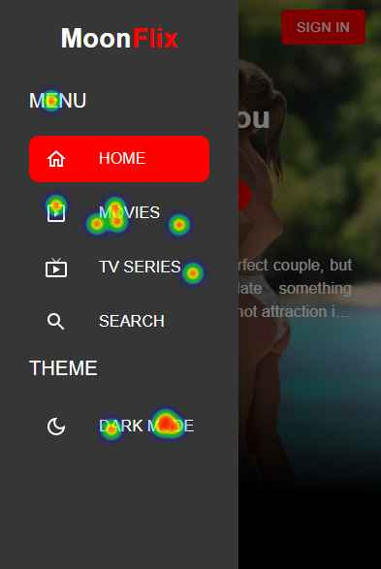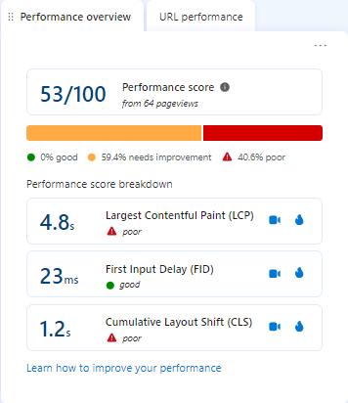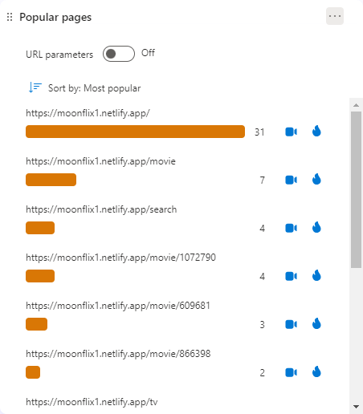

**User behaviors**

* **Desktop Users:** Scrolled through the entire page, mainly interacted with the play button and the main banner.
* **Tablet Users**: Did not visit the page, indicating a possible lack of interest or awareness.
* **Mobile Users**: Showed the most engagement by:
  + Scrolling to the middle and through the entire page.
  + Clicking on various elements such as the menu icon, the ‘watch now’ button of the main banner, and the second link of the sidebar menu.
  + Showing interest in the website’s navigation and branding by clicking on the Moon logo and the hamburger menu icon.
  + Interacting with movie posters and genre chips in the carousel, indicating a search for more information or filtering options for the movies.

**Key takeaways**

* **Content Variety:** Use more engaging and descriptive titles and images for slides and sections to encourage more clicks.
* **Tablet Optimization**: Conduct research and testing on user preferences and behavior on tablets, and adjust the design and layout accordingly.
* **Sidebar Menu**: Make menu items more visible and clickable, and provide feedback or confirmation when users select an option to reduce dead clicks.
* **Responsive Design**: Optimize the website for desktop and tablet users by ensuring that page elements are visible and functional on different screen sizes and devices.
* **Engaging Features**: Use more engaging and interactive elements, such as animations, hover effects, ratings, reviews, or trailers, to attract and retain users’ attention and curiosity.
* **Genre Chips**: Ensure that genre chips are clickable and lead to relevant results, or remove them if they are not intended to be filters, to reduce the possibility of dead clicks.

1. **Conclusion**:

Using user behavior and heatmap data, we get a full picture of how users interact with the Movie review website. If we use the suggested strategies, the Movie review website can make users more engaged, improve their experience, and get better conversion rates.

1. **References**

* <https://cypressnorth.com/conversion-optimization/microsoft-clarity-benefits-drawbacks-a-comprehensive-review/>
* <https://www.searchenginejournal.com/microsoft-clarity-analytics-overview/419311/>
* <https://learn.microsoft.com/en-us/clarity/setup-and-installation/clarity-setup>
* <https://learn.microsoft.com/en-us/clarity/>
* <https://clarity.microsoft.com/>